Lee Virtual Mobile App and Google

Shelby Smith: shelbatron1000@gmail.com

The following Setup instructions need to be completed before April 20th if the school desires the code project to be delivered with full integration with their own Google Calendar and Google Sheets.

Contents

Google Developer’s Console 1

Google Calendar 4

Google Sheets 6

# Google Developer’s Console

The Google Developer’s Console is where you will be registering the mobile app so that it can use the Google Calendar and Google Sheets APIs. You can also monitor the request traffic on the dashboard. The current ***free account*** Quotas seem sufficient for this small-scale mobile app (as seen on the menu: “IAM & Admin” -> “Quotas”). The setup is as follows:

1. To setup the app please login to the Google Developer’s console or create a Google account. This Google account will be used to be the owner of the application so please make sure you log in using the desired account.

<https://console.developers.google.com/>

1. After being logged in, please click “Manage Resources” under IAM & Admin menu option.

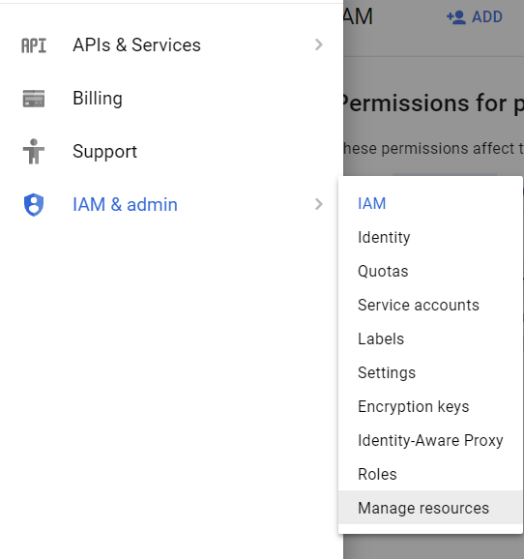

1. Click “Create Project”



1. Give the project a name and click create.
2. **Send your chosen project name to the FGCU Developer Team.**
3. You should now see you project under the Manage Resources page.
4. Click “Library” under APIs & Services.

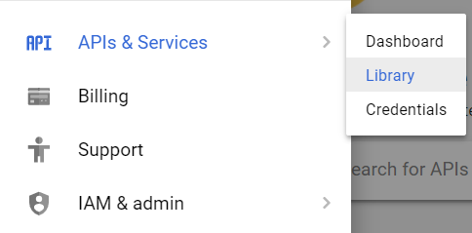

1. Search for the “Google Calendar API” and then enable this API.

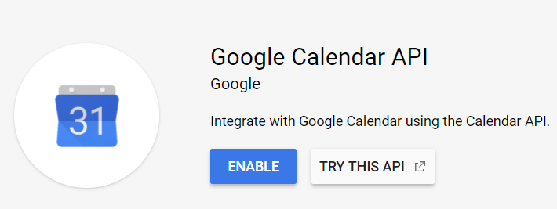

1. Select the “Create Credentials” button in the top right. (If you do not see this button, click on “Credentials” under the APIs & Services menu option.)



1. Click “API Key” in Step 1.

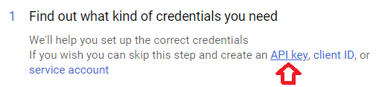

1. Name the API Key and “Create”. Keep Application restrictions at “None”.

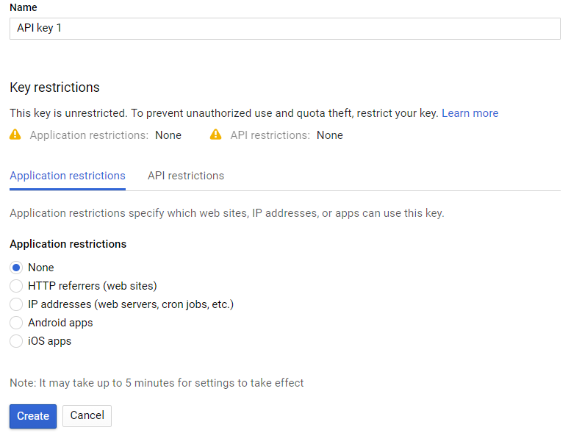

1. **Copy the API key shown on the screen and send to the FGCU Developer Team.**
2. Click “Library” under APIs & Services as shown in step 7.
3. Search for the “Google Sheets API” and then enable this API.

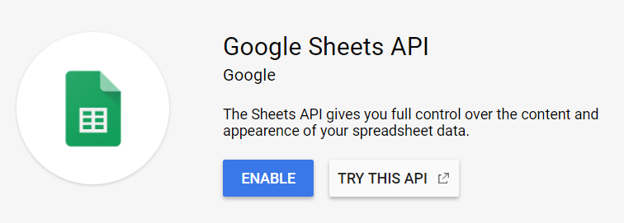

**The Google Developer’s Console setup is now complete. Please send the PROJECT NAME and API KEY to the FGCU Developer Team.**

# Google Calendar

The Google Calendar will be used to keep track of school events in the mobile app. Please note that this is ***one*** Google calendar (a user on Google can create many different calendars). The mobile app currently supports only pulling this information from an event: Title, Start Date and Time, End Date and Time, Location, Notes, if the event is All Day, and if the event is a repeating event. The setup is as follows:

1. Click the following link and sign into the **same Google Account** used in the Google Developer’s Console setup.

<https://www.google.com/calendar>

1. Add events to your Google Calendar. Make sure all events are added to one calendar.

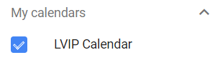

1. Click the Settings symbol in the top right of the page and select “Settings”.

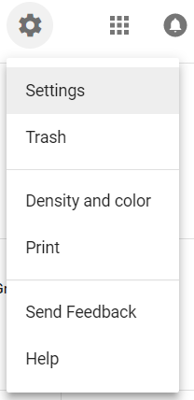

1. Click on the Calendar on the left menu.

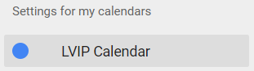

1. Scroll down to the “Access permissions” section and check the box “Make available to public”.

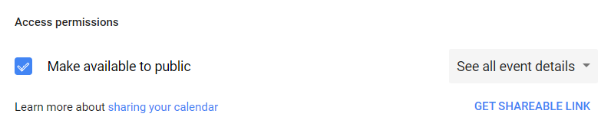

1. Scroll down to the “Share with specific people” section and add anyone you want to have access to edit events on the calendar (Teachers or Staff). While adding them, make sure to select the appropriate option of “Make changes to events”.

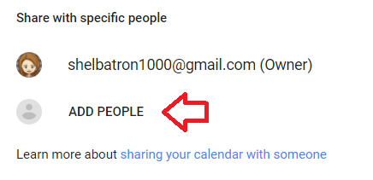 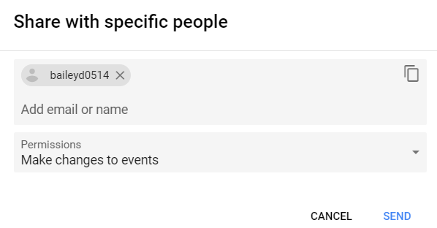

1. Scroll down to the “Integrate calendar” section and identify the Calendar ID. **Send this Calendar ID to the FGCU Developer Team.**

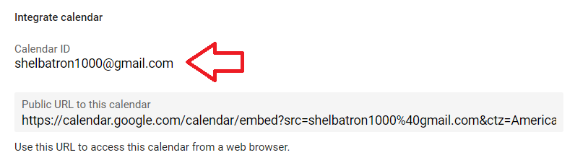

**The Google Calendar setup is now complete. Please send the CALENDAR ID to the FGCU Developer Team.**

# Google Sheets

The Google Sheet will keep track of the teacher data to be displayed in the mobile app. It is extremely important that the formatting is the same as the given template since the mobile app parses the information in the sheet. Setup is as follows:

1. Click the following link and sign into the **same Google Account** used in the Google Developer’s Console and Google Calendar setup.

<https://docs.google.com/spreadsheets/>

1. Create a new Blank Sheet.

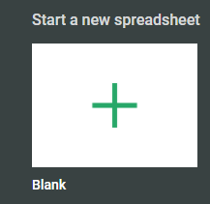

1. Copy the following example into the Sheet (either below or from the link to the Template). Make sure the first column/first cell begins at A1.

|  |  |  |  |  |  |
| --- | --- | --- | --- | --- | --- |
| **Grade Type - MUST be "Elementary" or "Secondary"** | **Name** | **Email** | **Phone** | **Hours** | **Notes** |
| Elementary | Mrs. Avery | karlaaa@leeschools.net | (239) 281-4712 | Thurs 9am-4pm | test note |
| Elementary | Mrs. Downey | monicasd@leeschools.net | (239) 822-0318 | Wed 1pm-3pm, Thurs 10am-12pm | test note |
| Elementary | Mrs. Gatewood | tricialg@leeschools.net | (239) 357-7602 | Please make an appointment | test note |
| Elementary | Mrs. Moore | AnaleeEM@leeschools.net | (239) 823-8065 | Mon- Fri 8am-8pm | test note |
| Secondary | Mr. Bruni | Jamesdb@leeschools.net | (239) 357-8038 | Mon 9am-12pm | test note |
| Secondary | Mr. McKinley | edwardamck@leeschools.net | (239) 822-9725 | Thur 3pm-4pm | test note |
| Secondary | Mrs. Ausman | MeaganMA@leeschools.net | (239) 823-2565 | Mon-Fri 7am-8pm | test note |
| Secondary | Mrs. Brooks | brittanypb@leeschools.net | (239) 357-2709 | Thur 1pm-4pm by Appointment | test note |

<https://docs.google.com/spreadsheets/d/1p12TY2VxI-6lDQENnQ8atwmr7vlqhodmDtByqXfpSyU/edit?usp=sharing>

1. Click on the **entire column A**. Then click on the menu option of “Data” and then “Data Validation”.

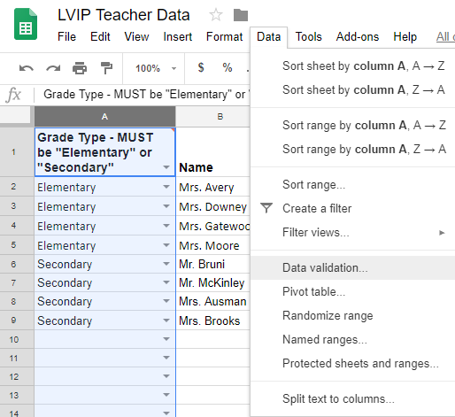

1. In the Data Validation box, select “List of items” for range and type “Elementary, Secondary” into the text box. Check “Show dropdown list in cell”, select “Reject input” on invalid data, and “Save”.

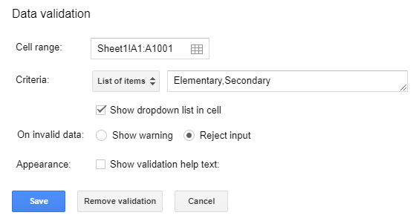

1. Click the “Share” button in the top right of the screen.



1. Select “Anyone on the internet can find and view” in the dropdown and copy the link given. **Send this link to the FGCU Development Team.**

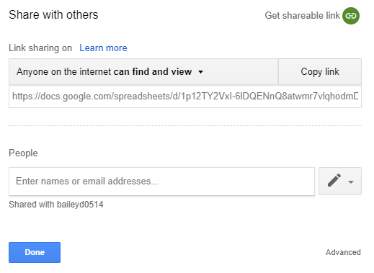

1. In the same “Share with Others” box above, you can allow other people (Teachers and Staff) to edit the **entire** Sheet by entering email addresses and clicking the dropdown and selecting “Can edit”. Select “Done” when finished. If you only want someone to add a certain range of cells, please see Step 10.

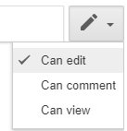

1. You can rename the Sheet now or keep it as the default “Sheet1”. After renaming the Sheet or deciding to keep the default name, please locate the Sheet name on the Tab at the bottom of the page. **Send this Sheet name to the FGCU Developer Team.**

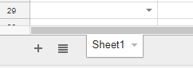

1. (Optional) If you are allowing the Teachers and/or Staff to edit the Sheet as shown in Step 8, you can restrict exactly what cells a person can edit. For example, if you want to restrict Mrs. Ausman to only editing her row (row 8 in the example), right click on the **entire row 8** and select “Protect range…”.

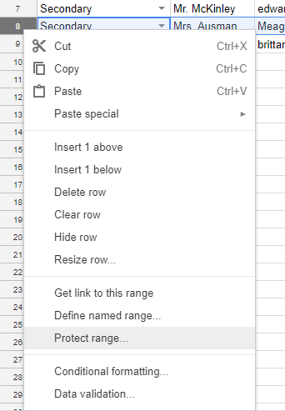

In the “Protected sheets and range” box to the right, optionally type a description, and click “Set permissions”.

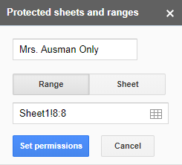

In the “Range editing permissions” box, select “Restrict who can edit this range” and check “Mrs. Ausman”, possibly deselect other editors, and select “Done”. For her name to appear in this section, you would have already added Mrs. Ausman in Step 8. Otherwise, you can add her by email in the textbox here.

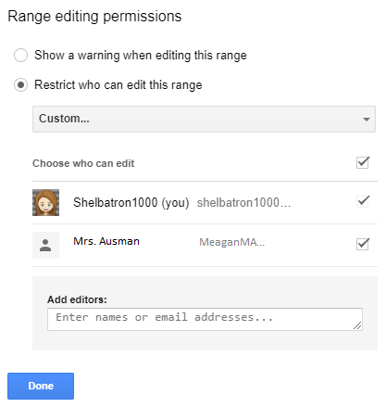

**The Google Sheets setup is now complete. Please send the SHARING LINK and the SHEET NAME to the FGCU Developer Team.**